**Azure BLOB CONFIGURATION**

This allows to store files in Azure blob storage(Cloud). It can be integrated very easily using API plug-ins.

1. CONFIGURATION

* Download files from GITHUB
  + Link: <https://github.com/Agileaxpert/Axpert>
* Import the structures in RUN instance using Axpert manager
* Create a html page in developer studio (say ABS) and add the JS and CSS files to the HTML page
* Create following keys in web.config and add proper Azure cloud values
  + <add key="ABSURL" value="https://usblob.blob.core.windows.net/blob/" />
  + <add key="ABSKey" value="?sv=2022-11-02&amp;ss= %3D" />
* Copy AxPlugins folder from GIT to AxpertWeb folder
* Add custom hyperlink to open this page from iview.

1. Screens
   1. Axpert Blob File storage

* There is a unique key called config ID .
* Trans ID is a drop down field on which entered form caption will be displayed.
* There is a key field which is a drop down on which entered key field caption will be displayed.
* Entering detail field is optional on which entered detail field caption will be displayed.
* There is a File Category which is a drop down with fields PO Copy , Letter, QC Report.
* Max field size can also be entered which is optional.
* File extension is a multi-select field which is mandatory to enter.

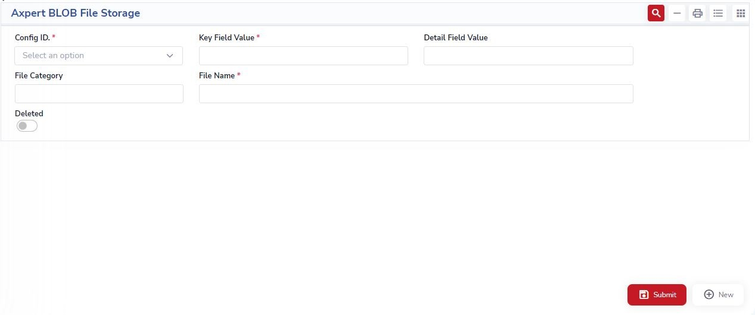

# Azure Blob File Storage

* There is a unique key called config ID .
* There is a key field value which is mandatory.
* There is a detail field value which is not mandatory.
* There is a File Category with fields PO Copy, Letter, QC Report.
* There is file name to be entered which is mandatory.



**PURCHASE ORDER LISTING:**

In the Purchase Order screen, data reflection will be facilitated through the Purchase Order Listing. A notable feature within this listing is the presence of an 'Upload' button. Upon clicking this button, users will be redirected to the File Upload Screen then we can create a new folders.

**Purchase Order Listing Report Screen:**

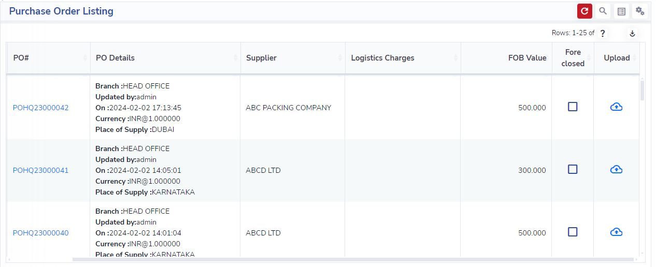

**File Upload Screen:**

